Muted voices of Female Gamers

Callie Whistle

University of Arkansas at Little Rock

ACOM 4300

Dr. Kristen McIntyre

May 7, 2018

**Abstract**

The purpose of this study is to explore how female gamers are treated while communicating in online games. As a gamer myself, I wanted to see if other female gamers shared similar experiences to my own or if they were different. I conducted a series of six interviews with female gamers. Through my data analysis using thematic analysis, I had six themes emerge. Two of which were connected to the Muted Group Theory by Edwin and Shirley Ardener. From those themes, I was able to make two claims with the help of Muted Group Theory.

**Introduction**

Online gaming was something that I had always wanted to get involved with because I loved playing video games. There were two things that kept me from joining the online community: not having the proper gaming system and fear. In the summer of 2010, I had saved enough money to buy myself an Xbox 360. That meant I had one of the two things I was lacking to start gaming online. During this time, I mostly continued to play solo campaign story games or I played with my older sister with the couch co-op split screen setting. In other words, we were able to play the game on the same console together. My screen would either be the right half or top half of the TV screen, depending on the game. And her screen would be the left or bottom half.

I was afraid of playing online with strangers because I believed that I would be forced to talk and listen to what the other players had to say. I was afraid of what the male gamers would do to me for being a female gamer. At that time, I was aware of the negative connotation of female gamers. I was at that point in my life where anything negative said towards me would have probably sent me into a downward spiral. I loved gaming - I still do. But I was afraid that someone I would never physically see would destroy what I loved from a single negative comment.

One of my guy friends would poke fun at me when I expressed these ideas to him. He thought my fears were ridiculous. He couldn’t understand what it meant to be a female gamer. He had never been a female once in his life. So how could he? It took a few months to convince him to play an online game with me. Mostly because he would cancel our plans. Because of my own experiences with online gaming, I wanted to know if other female gamers felt the same way I did or differently. I argue that the context of the game determines if female gamers are muted. I will first go over the literature that I reviewed and the Muted Group theory, next explain the methods I used while conducting my research, then I will discuss my findings with you, and finally, I will go over the limitations and recommendations I found.

**Literature Review**

Video games have become a popular media consumption over the last few decades. When video games were first introduced, they were thought to be strictly for the male audience. Recently, however, more and more females are making it known that they enjoy playing these same games as well. I’d like to explore the communication experiences these women have dealt with. I believe it’s important to understand this because of how popular online gaming has become. Also, this is important because I believe that there is still a stigma when it comes to females and gaming.

In my research, the first theme that I found in common between the articles I obtained was gender roles (Gray, Buyukozturk, & Hill, 2016; Martey, Stromer-Galley, Banks, Wu, & Consalvo, 2014; Ogletree & Drake, 2007; Paaßen, Morgenroth, & Stratemeyer, 2016; Wilhelm, 2018). It’s suggested that men are considered to be “true” gamers because they statistically play more games a week than women do. Research has shown that women tend to spend less time playing games because they must fulfill other duties or tasks (Paaßen, et al., 2016, p. 424). In our societal norm, women are viewed as the caretakers of the home. They are thought to be the ones who cook dinner, clean the house, and care for the household members. They also have to factor in time for school, work, or both. Paaßen, et al. suggests that in gaming culture, if men are continuously seen playing the role of the gamer than women are, then there will be a continued gendered association towards gaming (2016, p. 427). The articles that I found also had a shared idea about gender roles: unlike male gamers, female gamers have to choose to either identify as either a gamer (meaning masculine) or a female (meaning feminine). But, according to Ogletree and Drake’s survey they conducted with the Bem Sex Role Inventory (BSRI), there was no correlation that masculinity is related to gaming between both men and women with the BSRI (2007, p. 540).

Another common theme I found in my research is sexual harassment towards women. I thought that Kuznekoff and Rose had performed an interesting experiment. They wanted to know the difference in responses gamers give to a male voice versus a female voice if any. They played a total of 245 multiplayer matches with about 1,660 unique gamers. They switched back and forth between playing a pre-recorded male voice and female voice. They found that on average, the female voice received negative comments from other gamers three times as much as the male voice, and also received more messages than the male voice (Kuznekoff & Rose, 2012). Martey, et al. (2014), Paaßen, et al. (2016), and Fox and Tang (2017) suggest that women have developed a coping mechanism while playing online games to deal with the sexual harassment. Some of these strategies include picking a gender-neutral username, strictly using text chat or avoiding communication with other players altogether, choosing a male avatar, and seek social support either inside or outside of the game they are playing.

Through all of this research, I still felt there was a gap. I couldn’t help but notice, these articles never mentioned sitting down and actually talking with female gamers. It could be because of a variety of reasons, such as the use of theory or using only a quantitative research instead of a qualitative. In the next section, I’d like to take a look at the Muted Group Theory and its concepts.

**Theoretical Lens**

While I was at the starting point of my research, I didn’t have a clue about what kind of theory I wanted to use. I had originally considered using the Coordinated Meaning of Management or Dr. Mirivel’s Model of Positive Communication. Except that, neither of these theories really fit with my research questions, which is what are the experiences that female gamers have while communicating in online games. While reading articles for my literature review, I kept coming across Social Role Theory. The researchers in the articles all had mainly used Social Role Theory while conducting their research. I looked into the theory, thinking I might be able to use it. After looking into it, I still felt that it was lacking in some areas. I decided I would wait to see what themes appeared from my data through thematic analysis, and determine a theory that best matches those themes. With each new piece of information found in a thematic analysis, it is then “examined in light of a particular research question in order to construct a tentative answer to the question” (Hancock & Algozzine, 2011, p. 67). From there, I discovered that Muted Group Theory, by Edwin and Shirley Ardener, best fit the themes in my data. In this section, I will be going over what the Muted Group Theory is, the theorists behind this theory, and of its two main concepts: mutedness and the “muting” process.

**Theory Overview**

Edwin Ardener, along with his wife Shirley Ardener, was a social anthropologist (Dewey, 2016). In his essay, Perceiving women, Edwin and Shirley continued exploring their theory on muted groups, and that women have been affected by it (Dewey, 2016). Talking only to men about women was problematic, Edwin believed (Dewey, 2016). Muted Group Theory (MGT) originally was used to showcase the differences between men and women back when it was first created in 1975. Over the decades, it has now branched out to race, social class, age, and so on.

MGT describes the dominant and subordinate relationships. As the model shows, there are two groups: the dominant group and the muted group (also known as the subordinate group). The dominant group decides on what is the standard language. This is why they have a solid line pointing towards the perception of reality. In contrast, the subordinate group does not use the standard language that the dominant group has set up. Since they do not adhere to the dominant language, their ideas aren’t always heard. This is why they have a dotted line leading towards the perception of language (Dewey, 2016). 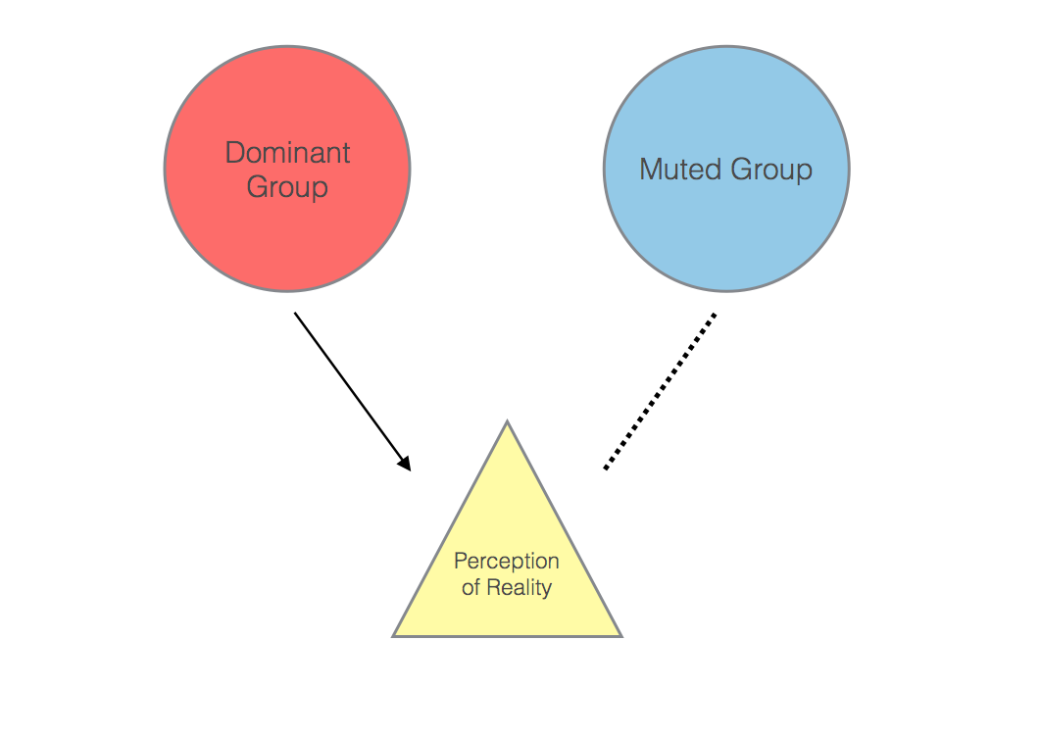

I believe this theory is appropriate for my research because, in the world of video games, men are still considered to be the dominant group in this industry. Despite the fact that the male to female ratio is roughly 55:45, it’s still considered to be a masculine past time. It’s because of this, and because I’m a gamer as well, I was very interested to look into the communications that other female gamers have while playing online. I wanted to see if I was the only one having certain experiences with male gamers. And the feeling of anxiety having to talk to other gamers in certain games while worrying if I’d get hated for being a female gamer. The key concepts that revealed itself by using this theory were mutedness and the “muting” process.

**Mutedness**

Mutedness is something that happens without changing the language the subordinate group uses, they cannot express their ideas. However, mutedness doesn’t mean the subordinate group is being silenced. They are allowed to speak, but only within the dominant group language (Dewey, 2016; Kramarae, 2005). One of the best examples I can think of is this scene from my favorite video game movie, *Wreck-It Ralph*. At the beginning of the movie, Ralph explains in his monologue how he’s the bad guy in his video game. However, he doesn’t wish to be the bad guy. He wants to be able to hang out and be part of the group with the other characters in his video game while in Bad Guy Anonymous. When he returns back to his game, he finds out he was not invited to his game’s 30th-anniversary party. When he shows up at the party, Ralph tries to express to the other characters that he’d like to be friends with them. Since the other characters view Ralph as a bad guy and because of the language choices that Ralph uses, Ralph is muted. He’s unable to express the idea of collaborating with the other characters.

**The “Muting” Process**

The “muting” process happens when the subordinate group is being controlled, harassed, and ridiculed by the dominant group (Dewey, 2016; Kramarae, 2005). Another example for the “muting” process also comes from the movie, *Wreck-It Ralph*. Later on in the movie, Ralph meets a young racer by the name of Vanellope Von Schweetz. In her game, Vanellope is not considered a “real” racer among her peers. She’s not allowed to race in any of the Grand Prix. At one point, Taffyta and the other racers destroy Vanellope’s kart in order to prevent her from racing with them. Later on, Ralph ends up destroying Vanellope’s latest kart to also prevent her from racing. At the end of the movie, it’s later revealed that King Candy had forcibly removed Vanellope’s programming from inside her game.

I just discussed a few of the different experiments and research the others have done in relation to female gamers, and the MGT and its concepts: mutedness and the “ muting” process. I’d like to move on to the methodology that I used for conducting my own research on the experience that female gamers have while communicating in online games. In which, I’ll discuss more in-depth on the context of my case, my data collection process, and the way I approached analyzing data.

**Methodology**

I first began thinking about what I wanted to research back in the fall of 2017. I knew for a fact that I wanted to focus on the ways that male and female gamers interacted with one another. Before Capstone started, I was still unsure about what my research question would be. I originally considered doing a focus on the interactions of gamers in tabletop games because I was just getting into Dungeons and Dragons that summer. By the time the fall came around, I wasn’t as interested in tabletop game interactions as I was with online games. In this section, I will be going over the context of my case, what video games are, what my participation criteria are, and how I collected and analyzed my data.

**Case Description**

You might be asking yourself: what are video games? Well, there are different types of games and genres. There are games that are more story based such as action/adventure and role-playing games (RPG). Then there are more competitive games such as first-person shooters (FPS) and massive online battle arenas (MOBAs). In these games, there are also sometimes specific roles that gamers can fulfill such as a tank, healer, and damage per second (DPS) classes. The tank is the character that has the most health points (HP). Because of this, they are meant to catch the attention, or aggro, the enemies. They protect the other party members from being attacked. The healer class does as the name suggest: they keep the party alive. Generally, the healer will constantly heal the tank character and heal the other party members as needed. And finally, the DPS characters will come in and chip away at the enemy’s health once the tank has the enemy’s full attention.

You might be wondering, “Okay… And how does the party know what to do?” Simply by communicating with one another. There are two main ways of communicating with others in a game: text chat and voice chat. With text chat, there is usually a small text box in the lower right or left side of the screen, depending on the game. A player can either click on the text box to start typing a message or by clicking either the enter key or T key on their keyboard. With voice chat, players use microphones that are either built into their headsets, computers, or one that’s plugged straight into their computer. If other players have their headphones or volume up on their computer, they can hear that person talking to them and vice versa. A player can have their microphone set to be constantly on, meaning that the microphone will pick up any and all sounds. Or they can have it set to push-to-talk. With push-to-talk settings, the player will hit a key that they press on their keyboard that they either hold down in order to speak or they toggle it.

Lastly, I want to go over what collaborative and competitive games are. Collaborative games are more feminine because, in these types of games, players are usually working together as a team to complete a common goal. An example of a collaborative game is *Final Fantasy 14*. In this game, in order to progress through the story, you are required to go through these dungeons with three other players. These can be either people that you know or random strangers. In the party, there is a tank, a healer, and two DPS characters. You work together to defeat all the smaller enemies as you progress through the dungeon until you finally reach the final boss. If your party completely dies, you’ll just have to start the dungeon over. Once the final boss is defeated, the party is award in-game currency, experience points (XP), and gear for your character. In contrast, competitive games are more masculine in the sense that you either win or lose. There’s no redo unless the opposing team is willing to have a rematch, which is not always the case. In these types of games, there are both solo and team-based competitive matches. The game *Fortnite* is a battle royale type of competitive game. In this game, a player can play a solo match against around 90 other players. Players start the match with no gear other than a pickaxe. They must scavenge for weapons, armor, and other resources while the play area shrinks as the match progresses. *Fortnite* also allows for team matches for teams of two, three, and four. The last standing player or team is the winner of the match.

**Ethnographic Approach**

At the very last minute, I decided that I wanted to go through the Institutional Review Board (IRB). I thought it was better to have their approval than to regret it later (See Appendix A). For my case study research, I did an ethnographic study. Doing Case Study Research, by Hancock and Algozzine, describes ethnography as exploring “the observable and learned patterns of behavior, customs, and ways of life of a culture-sharing group” (2011, p. 35).

In other words, I wanted to be able to look into the gaming culture. Specifically female gamers. From there, my research question for this study emerged. Which is “how are female gamers treated while communicating in online games?” I explored the gaming culture through the female perspective by interviewing members of the community in order to answer this question. I wanted to see if other female gamers had similar or different experiences than my own while in online games.

**Participants**

My criteria for potential interviewees were:

1. Must be female
2. At least 18 years old
3. Must play games regularly (console, pc, or possibly table top)
4. No mobile games/casual games
5. Preferably they play games online

I was worried that during the interview I would discover that the woman I’m interviewing did not fit my criteria, so I opted to create a pre-screening survey that is only 12 questions (See Appendix B). I felt this was the best approach to guarantee my participants fit my criteria and also to make sure that I’m not pressuring people to participate. I sent out my pre-screening survey through email and social media. In my pre-screening, I had it set up to where the survey will end if a person answers “no” for both questions that ask “do you play video games?” and “are you comfortable being interviewed?” This is because the questions after those two pertain to 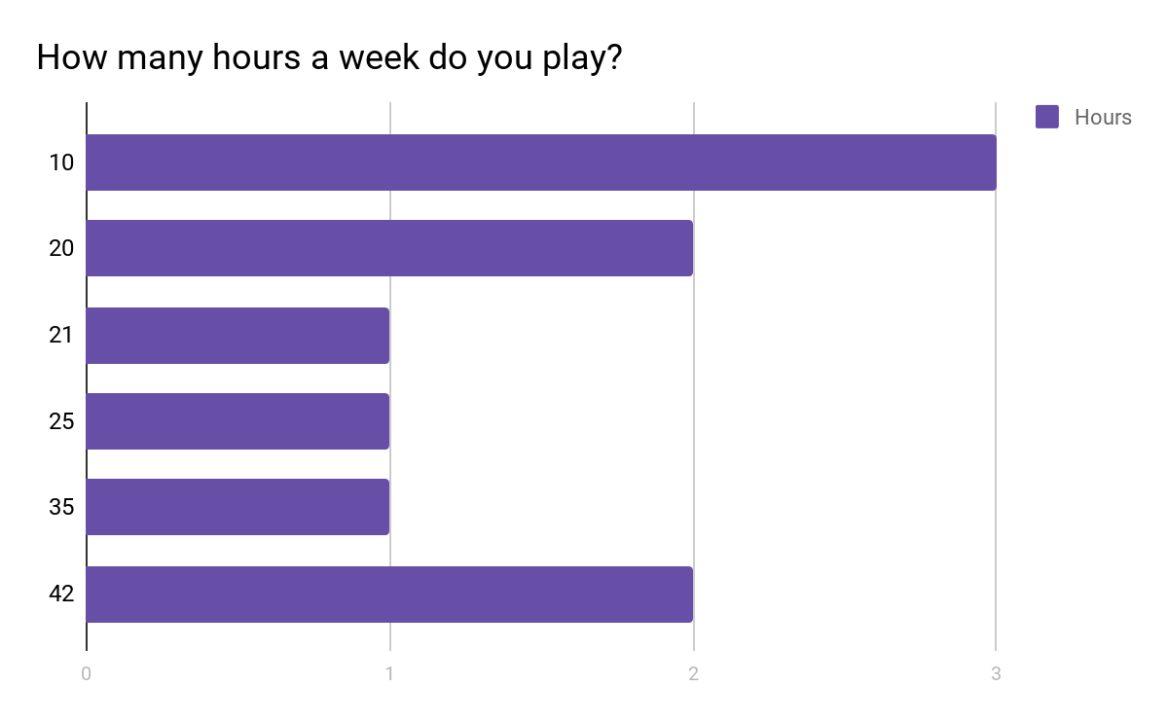both video games and more information about being interviewed.

*Figure 1.* Information about some of my potential participants.

I asked this particular question shown in Figure 1 on my pre-screening survey because I felt that I could get an idea of what kind of gamer these potential participants. I also had two other specific questions about the genre they play and gaming console they play on for this very reason.

**Data Collection**

I was lucky enough to have six women who fit my criteria and were willing to be interviewed (See Appendix C). Two of the interviews were done face-to-face, and the other four were done with Skype and Google Hangouts. Each interview lasted between 30 to 60 minutes. During the interview, I took notes about the participants’ facial expressions, attitudes, and the way that they respond with their nonverbals. I used two audio recorders while interviewing so that I would be able to transcribe the interviews later. It turned out to be a good thing that I did that. During my interview with Ryoushi, after I had relocated to another room while we were on Skype, I had apparently forgotten to turn one of my recorders back on. I noticed this towards the end of our interview.

**Data Analysis**

Once the interview had been conducted, I began transcribing. I mostly used Google’s voice to text tool in Google Docs to help me get through the transcription process more quickly. Once the interviews had been transcribed, I analyzed my data using a thematic analysis approach. Because I didn’t know what kind of theory I wanted to use yet, this was the best way to discover my theory. With a thematic analysis approach, I looked for themes to emerge and matched them to MGT (Hancock & Algozzine, 2011, p. 67). In Table 1, you can see my code book and how I coded my data.

|  |  |  |  |
| --- | --- | --- | --- |
| Code | Category | Definition | Data Examples |
| M | Mutedness | Female gamers are unable to express their ideas. | “Dominated by men.”; “like it’s just like bro time for them.” |
| MP | The “Muting” Process | Female gamers are being controlled, harassed, and ridiculed. | “He started yelling at me.”; “especially slut, guys would say that a lot.” |
| GDP | Gender Differences Perception | The perception a female gamer has of the differences of male and female gamers | “My husband and I role reverse.”; “I would think guys have it a little bit easier.” |
| E | Emotion | What a female gamer feels while playing in a game. | “It irritates me.”; “generally calm.” |
| MC | Mode of Communication | How a female gamer communicates. | “Voice chat.”; “Text chat.” |
| CS | Coping Strategy | The techniques that female gamers use to manage their gaming experience. | “I don’t turn the headset on.”; “I do gender change a lot.” |

*Table 1.* Code Book

So, to recap, I chose to research female gamer’s experience with communications because I am a female gamer. In order to collect data, I interviewed 6 women and analyzed my data using a thematic analysis approach. In this next section, I will be going over the results that I found while analyzing my data.

**Results and Analysis**

The reason I wanted to explore the experiences that female gamers have while communicating in online games is that I wanted to see if other women had similar experiences to my own or not. I will be going over the themes that presented itself within my data, and also my claims that emerged from my data.

Because I was unsure about which theory I wanted to use, I used a thematic analysis approach through emergent coding. When I first started the bracketing process to my transcriptions, I found that I had 2,484 units of data. However, upon further inspection, during my coding process, I decided that I only truly had 1,617 units of data. The remaining 867 units of data did not answer my research question. So, I opted to leave that portion of data out. Within those 1,617 units of data, 1,116 units connected with MGT. Nearly split 50/50 between mutedness and the “muting” process concepts as you can see in Table 2.

|  |  |  |
| --- | --- | --- |
| Participants | Code |  |
|  | M | MP |
| Valerian | 53 | 70 |
| Amirat Albira | 96 | 89 |
| Trivia | 97 | 119 |
| Ryoushi | 120 | 88 |
| madame_muff | 84 | 33 |
| ur_a_butt_waffle | 98 | 133 |
| Total Time Code Appears | 584 | 532 |
| Percentage of Occurrence | 35% | 32% |

*Table 2.* MGT results table. Shows the results for the codes for mutedness (M) and the “muting” process (MP).

As you can tell from Table 2, the difference between the occurrence of mutedness and the “muting” process was just merely 3%. I was surprised by both how close the two were and also by the frequency they had appeared in my data. Each of my participants was very eager to talk with me about their gaming experiences. When I asked them questions about their interactions with both male and female gamers, they weren’t afraid to share any negative stories that resulted in them being muted. The one thing that really surprised me was that Amirat Albira had a low percentage of occurrence for both mutedness and the “muting” process considering she had the most units of data, clocking in at 654. I think this is because she was more interested in talking about things that didn’t really fit my research question. In Table 3, the other four themes that didn’t necessarily pertain to MGT are listed.

|  |  |  |  |  |
| --- | --- | --- | --- | --- |
| Participants | Code |  |  |  |
|  | GDP | E | MC | CS |
| Valerian | 42 | 19 | 12 | 6 |
| Amirat Albira | 62 | 49 | 25 | 17 |
| Trivia | 55 | 11 | 11 | 0 |
| Ryoushi | 49 | 31 | 35 | 9 |
| madame_muff | 33 | 14 | 2 | 7 |
| ur_a_butt_waffle | 56 | 18 | 11 | 13 |
| Total Time Code Appears | 297 | 142 | 96 | 52 |
| Percentage of Occurrence | 17% | 8% | 5% | 3% |

*Table 3.* Shows the results for the codes for gender differences perception (GDP), emotions (E), mode of communication (MC), and coping strategy (CS).

I felt that it was still important to include these four other themes even though they didn’t exactly align with MGT. In my interviews, I asked a wide range of questions because I was unsure of what theory I would be using. There were a few questions in which I asked specifically about the women’s perspective on the difference between male and female gamers. There were also other instances in which they brought it up themselves in questions that didn’t ask about gender specific things. I also felt the same way towards the emotions code. There were a few instances in which I asked specifically how something affected their gaming experience. But there were other times when the women spoke outright about their irritation that was either towards other players or game mechanics. The modes of communication are referring to the choice of talking with other players through text chat or voice chat. Or, in madame_muff’s case, the refusal of using either mode by not talking back to the other players. And lastly, I wanted to see how each of the women managed any unwanted behaviors from other players by asking them about their coping strategies. It was interesting, to say the least. Each of the women had a different strategy, such as being indifferent, not using either chat systems, and strictly playing as a male character. From my analysis, I was able to make 2 claims.

**Female gamers are subjected to the “muting” process when they reveal their gender in game**

With the exception of Valerian, the other women expressed how negatively male gamers communicated with them once their gender was known:

*“If they find out I'm a girl that usually is like ‘Hey what's up?’, ‘How are you doing?’, 'So you got a boyfriend?’, ‘Do you play this a lot?’ You know, kind of like inquiring that sort of thing. ...I've had some creepers. ...Like ‘What do you look like?’, ‘Are you seeing anybody?’ Just weird stuff...”* - ur_a_butt_waffle, *Monster Hunter* and *Fortnite*

*“I think I was playing [Call of Duty] Modern Warfare. And well, I think that they figured out it was a girl because of the squeaky voice. And then they just started ganging up on me, and just started going after me.”* - madame_muff, *Grand Theft Auto*

*“I had one player - I was doing my rotations. Nothing was wrong. I was actually out DPSing him. And I guess it was him and his friends or something. Cause all the sudden, he started yelling at me, cursing at me, and then was doing rude emotes at me, and then I was kicked from the group. And I’m like... ‘What just happened?’”* - Amirat Albira, *Final Fantasy 14*

The women I spoke with all unanimously agreed that they weren’t hiding their gender, but at the same time, they also weren’t promoting it. They knew that they could potentially be inviting unwanted behavior from the dominant group. They also expressed their hatred and irritation towards this behavior from the dominant group. Which led them to do some gatekeeping by muting the mics of the other player or kicking the player that was bothering them out of the group. Some of them also started implementing their coping strategies, such as the ones suggested by Martey, et al. (2014), Paaßen, et al. (2016), and Fox and Tang (2017), by strictly playing as a male character, messing with the dominant group, or strictly talking through text chat with strangers. If you recall, Kuznekoff and Rose (2013) had performed the experiment of the difference in reactions from other players towards a male voice versus a female’s. The results were that the female voice had received more negative comments than the male voice had.

**Female gamers are less likely to experience being muted while playing with a group of friends.**

Each of the women spoke fondly about how much fun they have gaming with friends:

*“...whenever I play with friends. We always forget that we are different in the sense that our genders are different because I'm yelling at them and they're yelling at me. And it's not that we're yelling at each other because I'm a girl and they're male or anything like that. It's because ‘Hey, you done messed up. Get your ass back over here so that I can heal you!’”* - Trivia, *Heroes of the Storm*

*“I just feel like as long as you're in the correct company online, and you're with good people, then the gaming experience should be pretty great, I feel. But if you're with a bunch of people who are not nice, then I suggest just looking for new friends or something like that.”* - Valerian, *Final Fantasy 14*

*“Playing with friends playing online is just goofy. Like I said, it's laid-back. I guess mostly you know you don't have to worry about someone being a jerk.”* - ur_a_butt_waffle, *Monster Hunter* and *Fortnite*

When a female gamer finds a group that they like to play with, they feel more at ease in an emotional sense. They can either goof off in a game with their friends or do something more serious, such as raiding or playing a team-based competitive match. Each of my participants told me that they don’t get as many negative comments or gendered slurs as much anymore since they were able to find a group to collaborate in. For the most part, they don’t have to worry about any animosity towards them being a female who enjoys gaming. They’re more willing to communicate through voice chat when playing with friends versus strangers.

I just discussed how I wanted to see the experiences that female gamers have while communicating in online games, and about my claims that female gamers are subjected to the “muting” process once they reveal their gender and less likely to be muted when playing with groups. While searching for participants, I had come across some limitations and also, found some recommendations.

**Implications and Recommendations**

Before even beginning my research, I was aware of the limitations I would be faced with. I wanted to share with people some of the issues that I came across so that if anyone would like to expand on my research or to prevent this from happening to themselves during their future research.

**Limitation and Future Research**

When I first started this research project, I was aware that there would be certain things that would be beyond my control. I definitely felt like I needed - and wanted - more time in order to expand my research.

**Methodological Issues**

At the end of March, one of the women who had taken my pre-screening survey reached out to me through Discord. I had initially rejected her because she had said she didn’t want to be interviewed. She explained to me that she chose that because of the differences in our time zones, and she thought it would be an open response that she could fill out anytime. She also told me that her spoken English wasn’t very good and worried that her accent would be too thick for me to understand. I told her I could work with that and asked her to first sign the consent form. I had to ask her several times because she kept ignoring the consent form topic. Finally, she asked me if she really had to sign the form. I explained to her that yes I needed it because of my IRB protocol, and I would get in a lot of trouble if I didn’t have the consent form signed. She explained to me that the reason she didn’t want to sign the consent form was that in her country, all you needed was a signature in order to take out a bank loan. She said it felt unnerving just to give someone overseas her signature.

I spent a few days talking with Dr. McIntyre on a course of action. This was something that neither one of us had expected to happen. We came to the conclusion that unless she was willing to sign the consent form, I could not accept her as a participant due to my IRB protocol. Because of my protocol, I was unable to accept any other forms of consent. Since the woman waited so long to message me, I did not have time to have my IRB amended. If she had contacted me two weeks prior when I had sent out the pre-screening survey, I could’ve had my IRB protocol amended to accept a recorded verbal consent. I gave her one last chance to sign the consent form, but she still refused. So I politely thanked her for her willingness to participate, but that I could not accept her as a participant.

**Future Research**

When I had first thought about researching the experience that female gamers have while communicating in online games, I really wanted to get the perspectives of both women and men. Growing up, I learned that there were always two sides to every story. It was brought to my attention back in January by a male peer to be wary of this research becoming a “victimizing” piece. That was never my intention for this research to be used like that. I actually worried that other people would only see my research as just that. Which is why I really wanted to include men in my research so that I could get their side of the story - their perspective. However, due to the time constraints I had, I was unable to expand my research as far out as I would like.

So, if I decide later in the future to continue this topic, I would love to get the male perspective. I remember in class that one of my classmates stated that they knew a guy who would act awful towards other players while gaming online, but in real life outside of the game, he was supposedly the nicest guy you would ever meet. I found that piece of information to be fascinating. It makes me wonder what drives a person to behave like that. Is it because of the sheer fact that they’re not interacting with someone face-to-face, so there aren’t any perceived repercussions? Or is it because of something entirely different?

I would also like to get a much larger sample size. I’m aware that six women do not speak for the whole group of female gamers. Again, due to time constraints, I was unable to get more participants. I believe that I need a larger sample size in order to fully understand female’s experience while communicating in online games. Of course, a larger sample size would also mean that it takes more time to sift through that data.

**Implications**

**Communication Discipline.** The whole point of this study was to gain a better understanding of how are female gamers treated while communicating in online games. I believe this is important because video games are always changing. I noticed that in some of my older academic articles I had found had become outdated while I reviewed them (Ivory, 2006; Ogletree, et al., 2007; Royse, Lee, Undrahbuyan, Hopson, & Casalvo, 2007). Certain things, such as there not being that many strong female protagonists in game, are no longer that big of an issue.

**Communication Theory.** MGT has allowed me to get a better grasp on why certain things happen in online games. I learned that not only do other players (both men and women) mute female gamers, but female gamers also mute themselves. Some of my participants admitted to muting themselves by either not talking to other players, or also by removing themselves from a game or gaming group. This theory was initially created to showcase the difference in power between men and women (Dewey, 2016). This same theory can also be applied to the communications that female gamers have with other female gamers. If a female gamer either feels her social standing is slipping or another female gamer is not acting according to unspoken rules, she will probably subject the “muting” process onto the other female gamer.

**Department Mission.** The Department of Applied Communication mission is “fostering the co-creation of better social worlds through positive communication” (Applied Communication, n.d.). For those wondering how video games pertain to our department’s mission, it’s quite simple. Just as I stated before, video games are always evolving. Video games were vastly different 10 years ago from how they are now. Nowadays, it’s difficult to find a video game that doesn’t have multiplayer online capabilities. With the use of text chat and voice chat, gamers are constantly communicating with other gamers. Which is why I believe it is imperative to practice positive communication even while playing games online.

**Recommendations**

**Case.** I suggest to my peers to not worry about being muted by the dominant group. When I asked my participants if they had anything extra they would like to add, the majority had said that if someone feels like gaming, then to just go out and do it. They said that the positives outweigh the negatives. For the most part, they found gaming to be a stress reliever. And the way the chat system works in games now, a person can select to either mute or kick a player from the group if they’re being bothered. Players are allowed this level of gatekeeping so that they can feel safe while playing a game.

**Community.** I suggest to the community, more specifically the gaming community, to be familiar with language protocols. When waiting for a game to start up, (especially with strangers) greet everyone on your team with a simple hello either in text chat or voice chat. This helps ease any stress or uncertainty with other players. It also allows players to feel more open to communicate with one another. Which helps everyone to stay calm if something doesn’t go right. At the end of the match, no matter if you win or lose, always end with a good game or a GG for short. This helps players from feeling like sore losers or gloating winners. It keeps players humble and prevents any animosity towards players from the opposing team or the game in general. Also, understand that trash talk is normal. Depending on a player’s tone of voice, it can be playful or harmful. I had some participants talk about how some strangers trash talked them but in a playful manner. It all depends on the context and tone of voice.

**Personal.** I suggest to myself to prevent the “muting” process by finding a gaming group to collaborate with. I will not worry so much while playing games online. That’s why I will focus on having fun with friends and the game. I have been invited to join in a game with some of the participants shortly after we concluded our interview. I am also going to check out this new gaming group that’s just now starting out in a few days. I’m not sure if I’ll enjoy it or not, but it’s definitely worth a shot. Gaming is a great way to make new connections.

I shared some of the limitations I had about not being able to accept a potential participant and unable to get the male perspective. I also went over how communicating in video games relates to our communication discipline, communication theory, and department’s mission, and my recommendations to my peers, to the gaming community, and to myself.

**Conclusion**

I argued that the context of the game determines whether female gamers are muted. In order to prove my hypothesis, I first gathered and reviewed literature that pertained to video games. Then I discussed what MGT is, the theorists behind it, and its two concepts: mutedness and the “muting” process in my theoretical lens section. After that, I explained the methods I used in order to conduct an ethnographic study. I had created and sent out a pre-screening survey in order to find participants. Once I found my participants, I contacted and then interviewed them. Once the data was collected, I began using thematic analysis while coding because I was unaware of the theory I would use. Then I shared my results that had emerged and linked itself to MGT, along with my claims that also emerged. And finally, I discussed the limitations that my research had and how I would expand on it in future research, along with some recommendations. As I said at the beginning of my paper, I was a nervous wreck when I first considered playing games online. Now, I play games to have fun and not worry about what others think. I feel like nothing can stop me or put a damper on my mood when it comes to gaming.

**References**

Applied Communication. (n.d.). Retrieved April 8, 2018 from http://ualr.edu/appliedcomm/

Dewey, J. P. (2016). Muted group theory (MGT). *Salem press encyclopedia.*

Fox, J., & Tang, W. Y. (2017). Women’s experiences with general and sexual harassment in

online games: Rumination, organizational responsiveness, withdrawal, and coping strategies. *New media & society.* 19(8). 1290-1307.

Gray, K., Buyukozturk, B. & Hill, Z. (2017). Blurring the boundaries: Using gamergate to

examine ‘real’ and symbolic violence against women in contemporary gaming culture. *Sociology compass.* 11(3). 1-8.

Hancock, D. R. & Algozzine, B. (2011). *Doing case study research.* New York, NY: Teachers

College Press.

Ivory, J. D. (2006). Still a man’s game: Gender representation in online reviews of video games.

*Mass communication & society.* 9(1). 103-114.

Kramarae, C. (2005). Muted group theory and communication: Asking dangerous questions.

*Women and language.* 28(2). 55-61.

Kuznekoff, J. H., & Rose, L. M. (2013). Communication in multiplayer gaming: Examining

player responses to gender cues. *New media & society.* 15(4). 541-556.

Martey, R. M., Stromer-Galley, J., Banks, J., Wu, J., & Consalvo, M. (2014). The strategic

female: Gender-switching and player behavior in online games. *Information, communication & society.* 17(3). 286-300.

Ogletree, S. M., & Drake, R. (2007). College students’ video game participation and perceptions:

Gender differences and implications. *Sex roles*. 56(7-8). 537-542.

Paaßen, B., Morgenroth, T., & Stratemeyer, M. (2017). What is a true gamer? The male gamer

stereotype and the marginalization of women in video game culture. *Sex roles.* 76(7-8). 421-435.

Royse, P., Lee, J. Undrahbuyan, B., Hopson, M., & Consalvo, M. (2007). Women and games:

Technologies of gendered self. *New media & society.* 9(4). 555-576.

Wilhelm, C. (2018). Gender role orientation and gaming behavior revisited: Examining mediated

and moderated effects. *Information, communication & society.* 21(2). 224-240.

**Appendix A**

**IRB Approval Letter**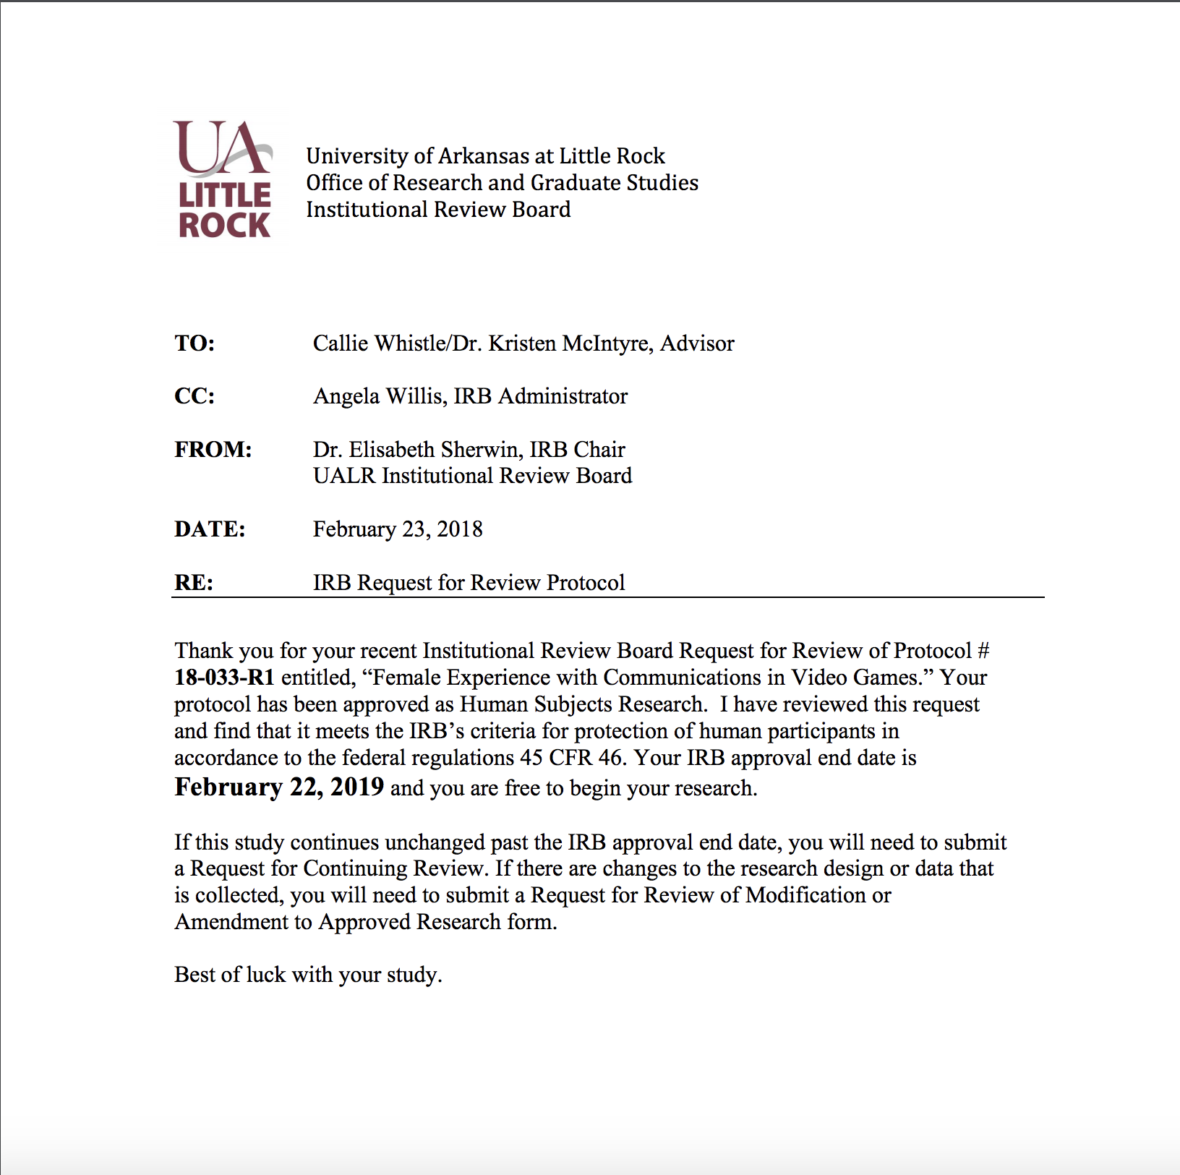

**Appendix B**

**Pre-screening Survey**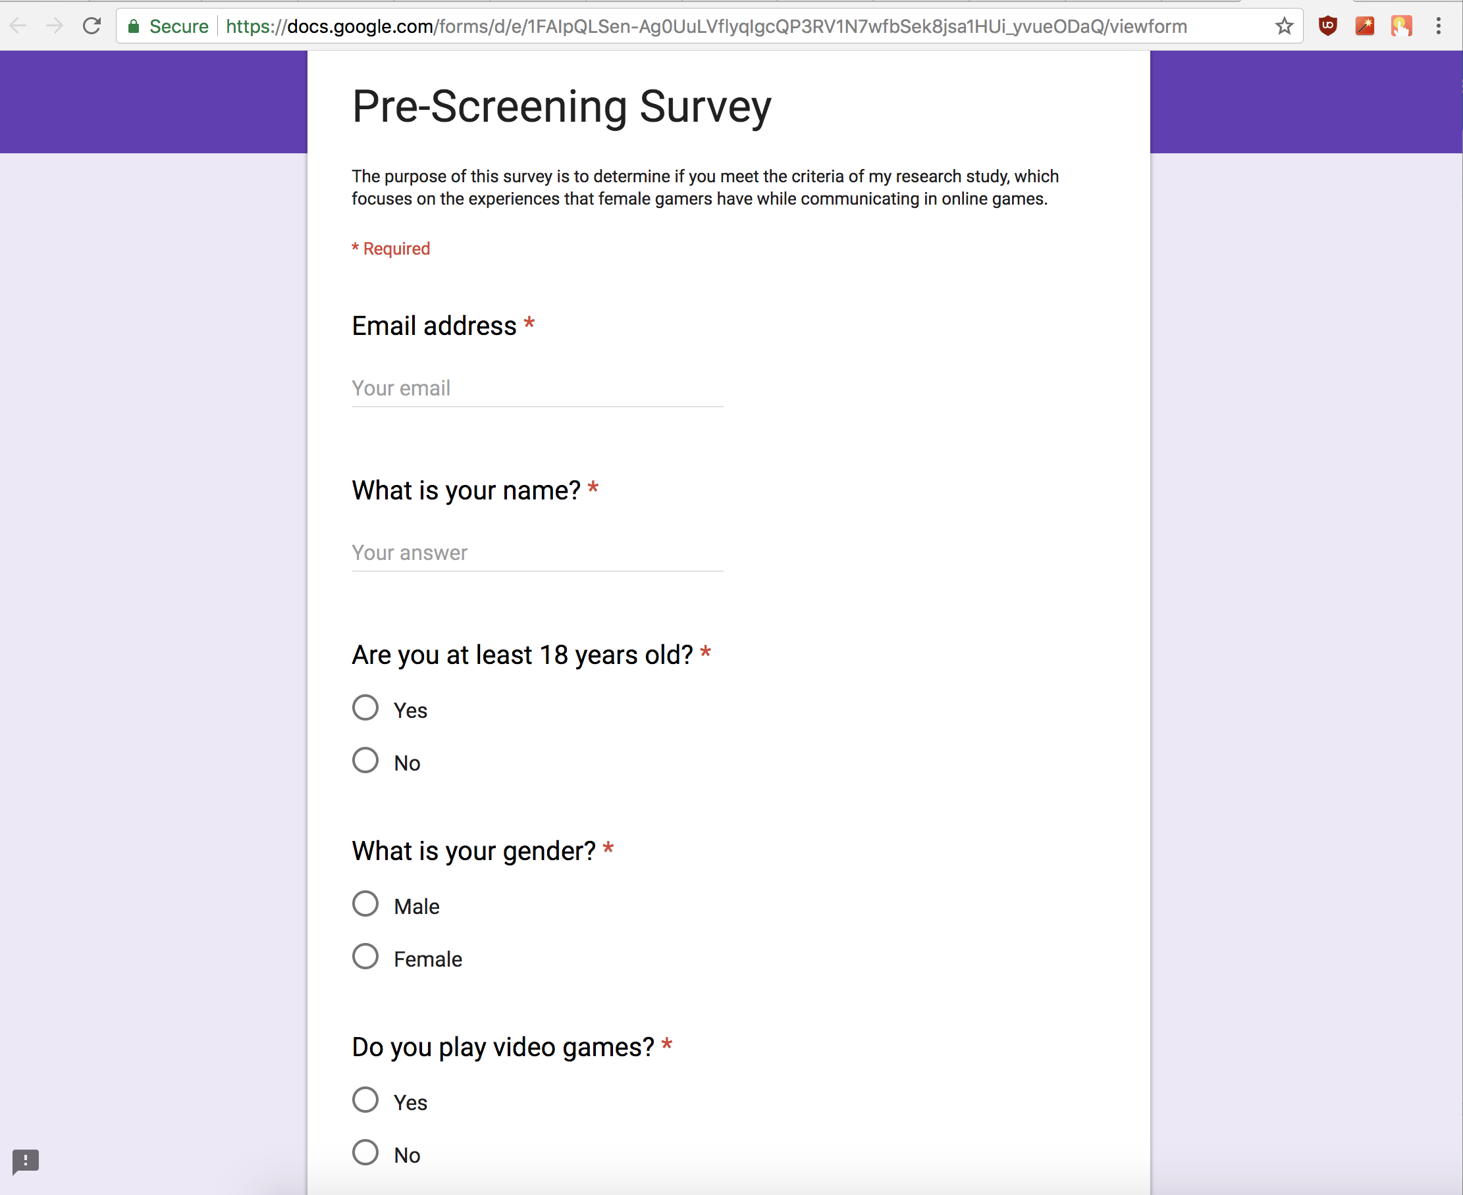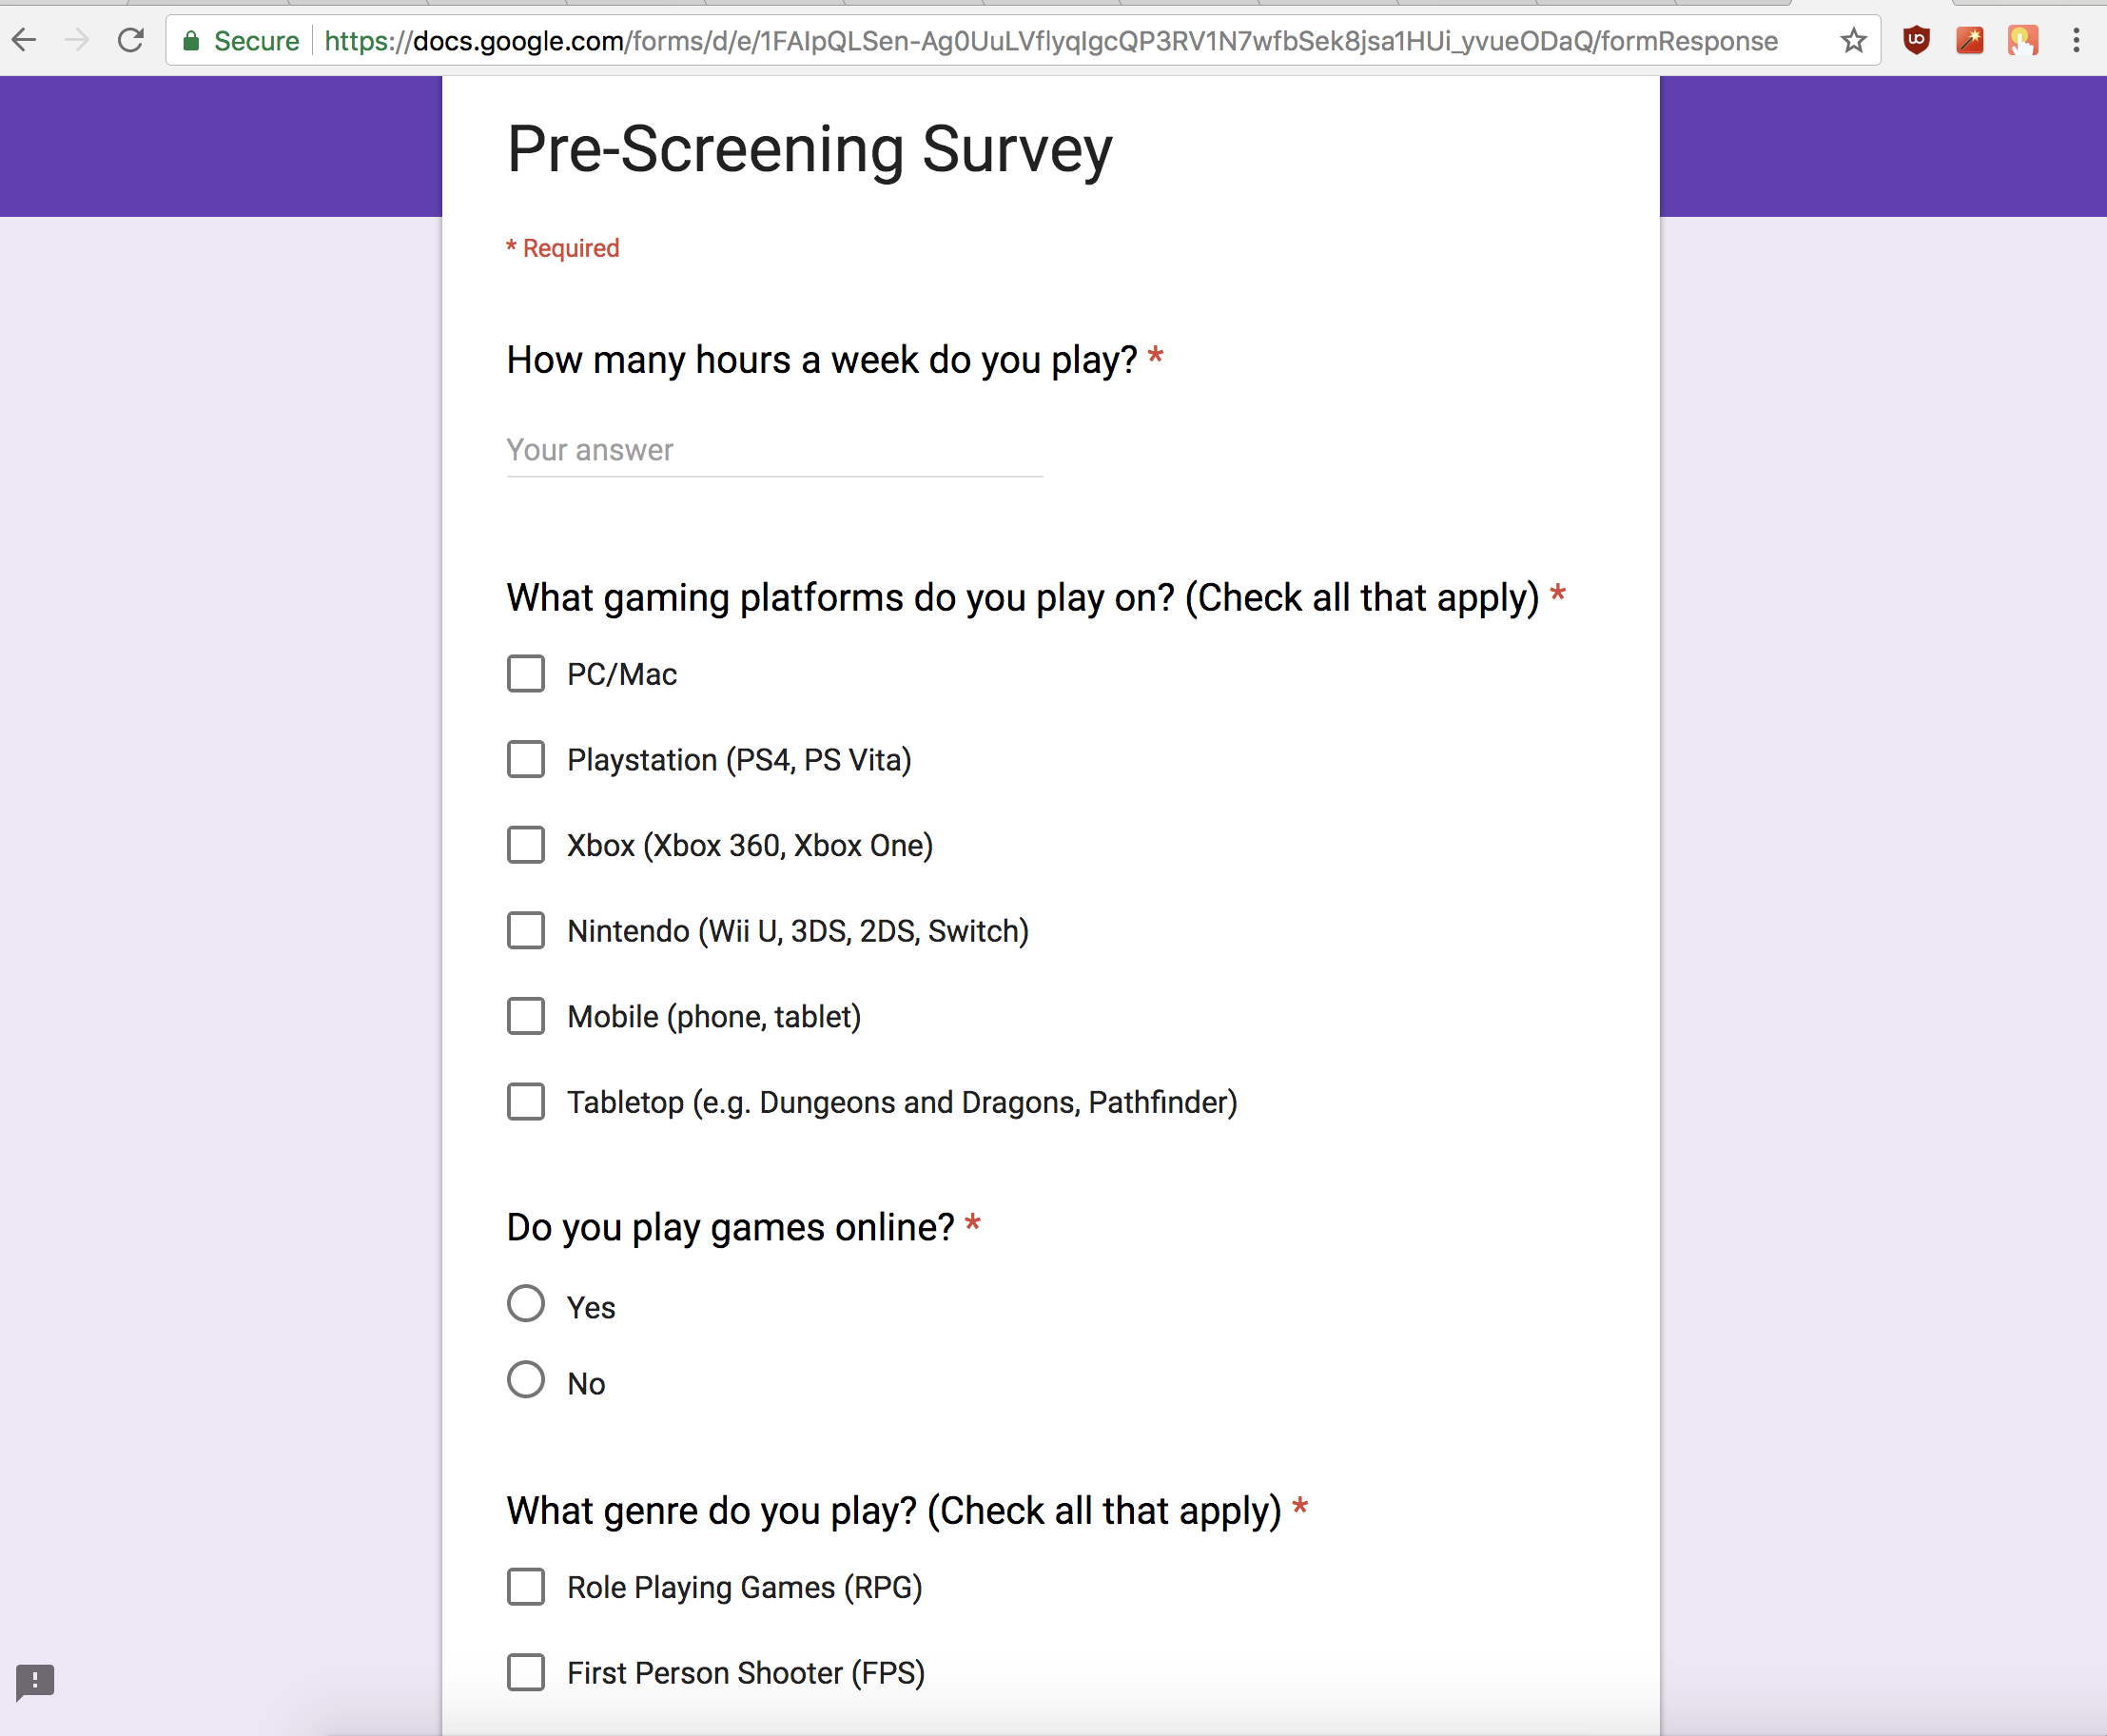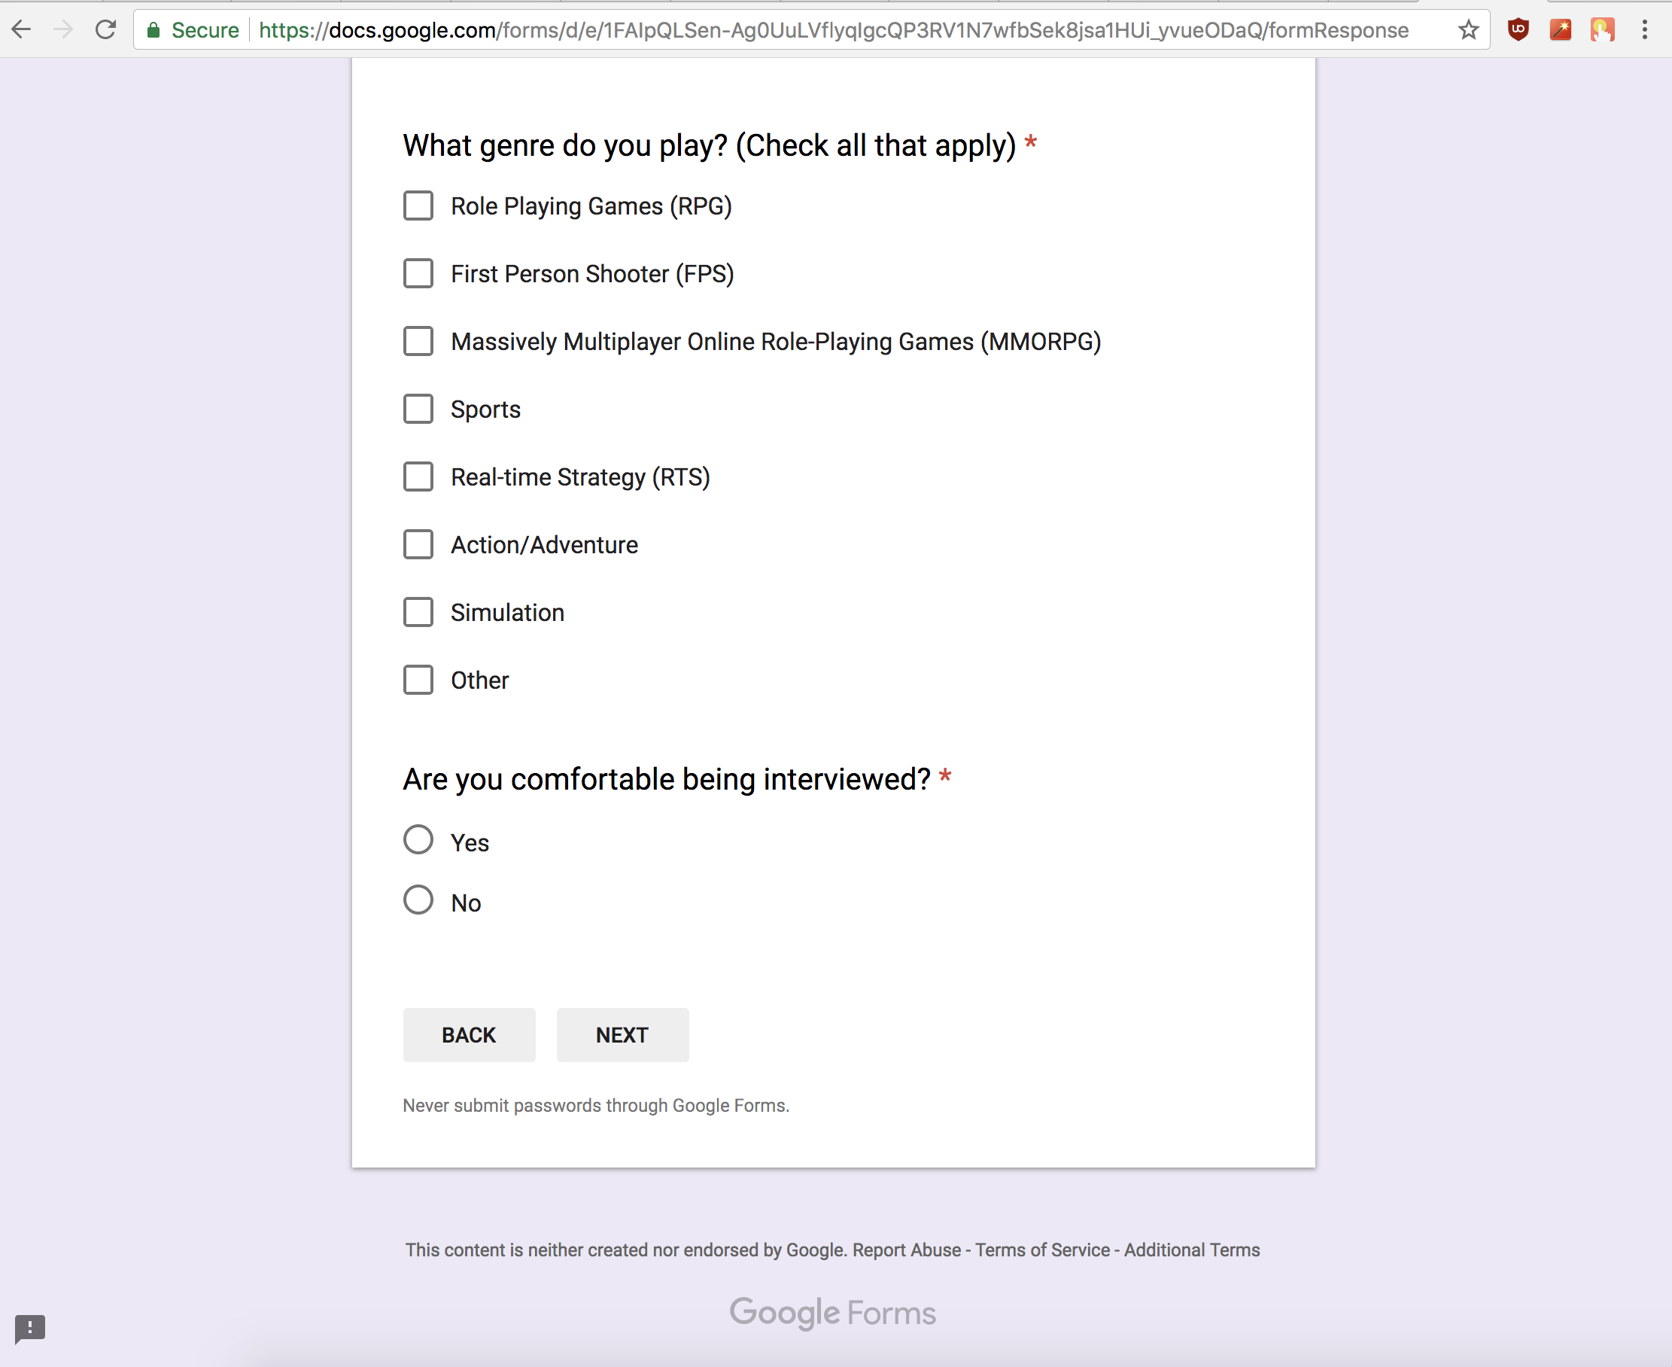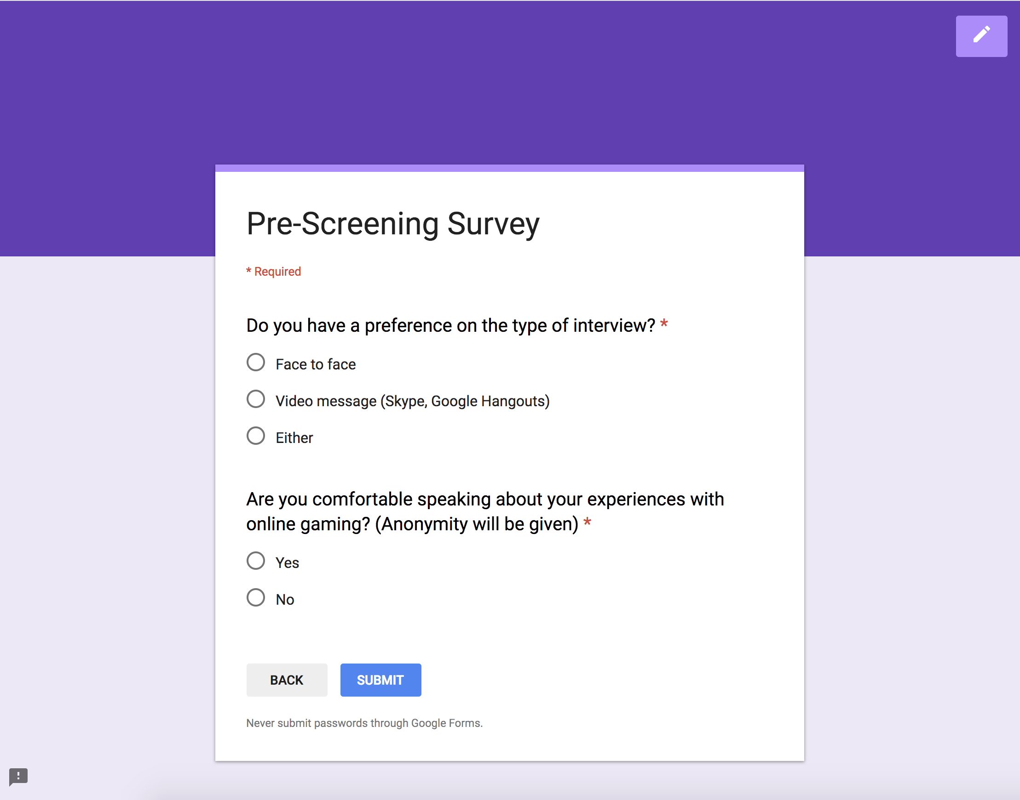

**Appendix C**

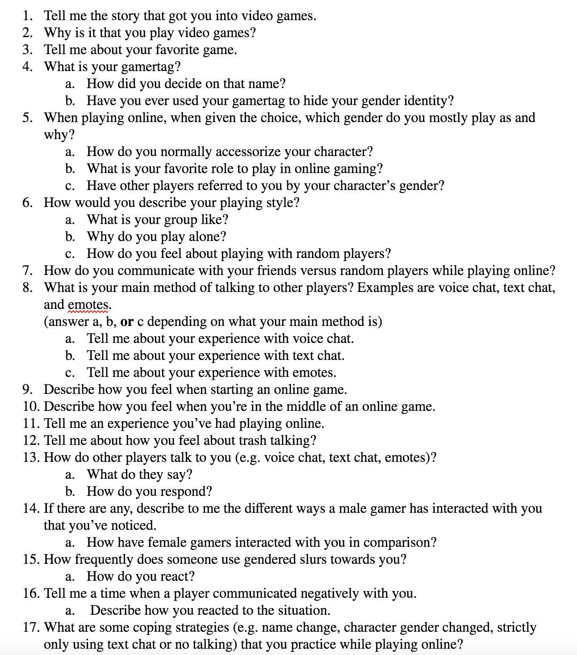**Interview Protocol**

